Scripts from Rstudio from Final Project

As mentioned in my repport, I ran into troubles with my installation of tidy, I problem I was unable to fix, therefore my Rmarkdown would not work properly. There I here added screenshots of my scripts in Rstudio

I all so added my raw data from smurf into my Github.

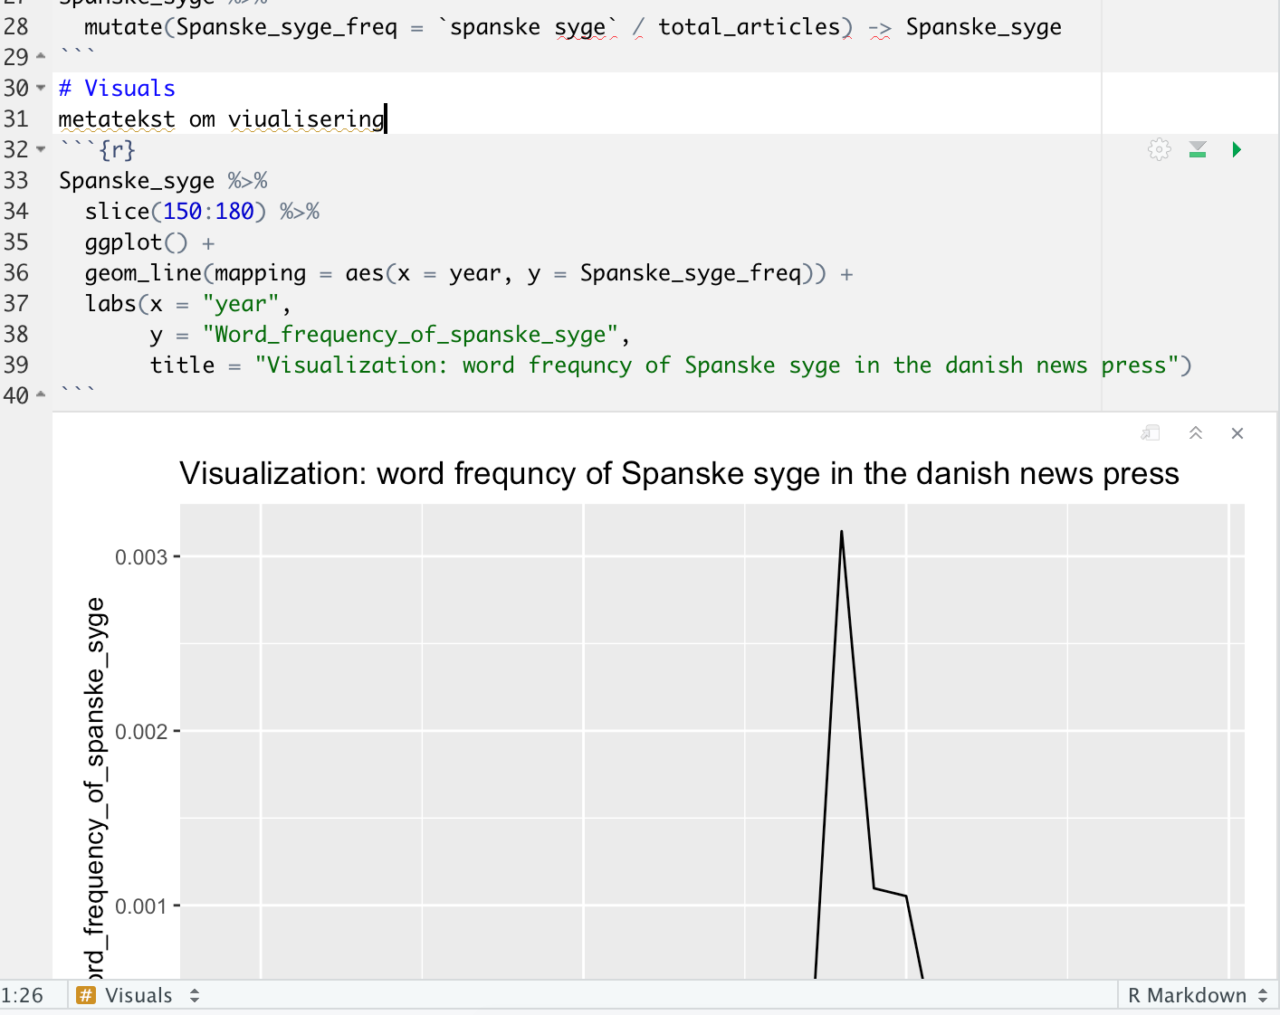

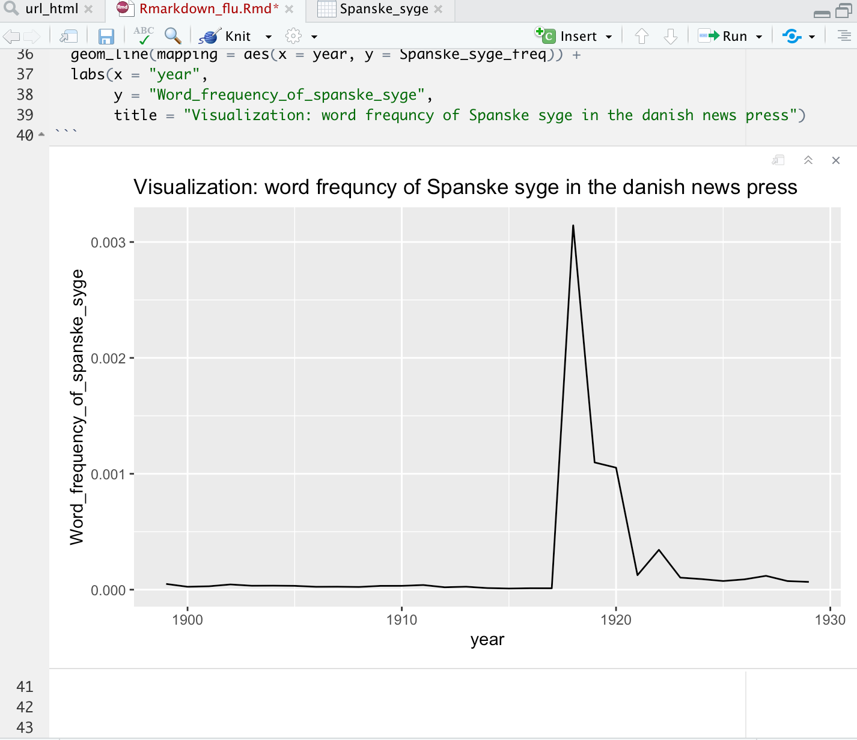

**RAW copy paste of my script**

title: "SPANSKE_SYGE"

author: "Bastian_Rytter_Lykkebo"

date: "12/3/2020"

output: html_document

---

# Packages/preparations

installing packages (alt + cmd + i)

```{r}

install.packages("tidyverse")

library(tidyverse)

# proccesing data

Metatext: this is the location of kb labs, smuf

```{r}

read_csv("Data/smurf-2020-12-03_14_47.csv", skip = 2)

Spanske_syge <- read_csv("Data/smurf-2020-12-03_14_47.csv", skip = 2)

```

# Analysis of data

calculation of realative frequences

den skal vide hvad det er, hvad betyder tallet 1? vi skal fortælle r at den skal regne i relative frekvenser

Nu laver vi pipes, vi fortæller den nu at vi arbejder inde i "spanske_syge" dataset (shift + cantrol + m)

Hvad foregår der i denne kode. Vi laver en ny kollonne så der kommer fire variabler i stedet for tre, fordi vi vil have den som beregner de relative frekvenser

```{r}

Spanske_syge %>%

mutate(Spanske_syge_freq = `spanske syge` / total_articles) -> Spanske_syge

```

# Visuals

metatekst om viualisering

```{r}

Spanske_syge %>%

slice(150:180) %>%

ggplot() +

geom_line(mapping = aes(x = year, y = Spanske_syge_freq)) +

labs(x = "year",

y = "Word_frequency_of_spanske_syge",

title = "Visualization: word frequncy of Spanske syge in the danish news press")

```